DSP Education Kit
LAB 1:
Analog Input and Output
Issue 1.0

Contents
1 Introduction 1
1.1 Lab Overview 1
2 Requirements 1
2.1.1 STM32F746G Discovery Board 1
3 Basic Digital Signal Processing System 2
4 Basic Analog Input and Output Using the STM32F746G Discovery Board 3
4.1 Program Operation of stm32f7_loop_DMA.c 6
4.2 Running the Program 8
4.3 Use of GPIO Pin for Timing Indication 10
4.3.1 Connect an Oscilloscope Probe to Pin D13 on Connector CN7 to Confirm Timing 10
5 Delaying the Signal 10
6 Creating a Fading Echo Effect 15
6.1.1 Exercise 18
7 Real-Time Sine Wave Generation 19
7.1 Program Operation 19
7.2 Exercise: Modifying the Sine Wave 23
7.3 Viewing Program Output Using MATLAB 24
8 DMA-Based Example Program 27
9 Conclusions 28
10 Additional References 28

Introduction

Lab Overview
The STM32F746G Discovery board is a low-cost development platform featuring a 212 MHz Arm Cortex-M7 floating-point processor. It connects to a host PC via a USB A to Mini-B cable and uses the ST-LINK/V2 in-circuit programming and debugging tool. The Keil MDK-Arm development environment, running on the host PC, enables software written in C to be compiled, linked, and downloaded to run on the STM32F746G Discovery board. Real-time audio I/O is provided by a Wolfson WM8994 codec included on the board.
This laboratory exercise introduces the use of the STM32F746G Discovery board and several of the procedures and techniques that will be used in subsequent laboratory exercises.

Requirements
To carry out this lab, you will need:
- An STM32F746G Discovery board
- A PC running Keil MDK-Arm
- MATLAB
- An oscilloscope
- Suitable connecting cables
- An audio frequency signal generator
- Optional: External microphone (although you can also use the microphones on the board)

STM32F746G Discovery Board
An overview of the STM32F746G Discovery board can be found in the Getting Started Guide.

Basic Digital Signal Processing System
A basic DSP system that is suitable for processing audio frequency signals comprises a digital signal processor and analog interfaces, as shown in Figure 1. The STM32F746G Discovery board provides such a system, using a Cortex-M7 floating-point processor and a WM8994 codec.
The term codec refers to the coding of analog waveforms as digital signals and the decoding of digital signals as analog waveforms. The WM8994 codec performs both the Analog-to-Digital Conversion (ADC) and Digital-to-Analog Conversion (DAC) functions shown in Figure 1.
Figure 1: Basic digital signal processing system
Program code may be developed, downloaded, and run on the STM32F746G Discovery board using the Keil MDK-Arm integrated development environment (IDE). You will not be required to write C programs from scratch, but you will learn how to compile, link, download, and run the example programs provided, and in some cases, make minor modifications to their source files.
To do this, you will learn how to use a subset of the features provided by MDK-Arm (note that using the full capabilities of MDK-Arm is beyond the scope of this set of laboratory exercises). The emphasis of this set of laboratory exercises is on the digital signal processing concepts implemented by the programs.
Most of the example programs are quite short, and this is typical of real-time DSP applications. Compared with applications written for general purpose microprocessor systems, DSP applications are more concerned with the efficient implementation of relatively simple algorithms. In this context, efficiency refers to speed of execution and the use of resources such as memory.
The examples in this document introduce some of the features of MDK-Arm and the STM32F746G Discovery board. In addition, you will learn how to use MATLAB to analyze audio signals.

Basic Analog Input and Output Using the STM32F746G Discovery Board
The example source file implements a simple audio “loop-through” using two DMA transfers. First, it programs the on-board digital microphone to sample at 16 kHz and hand its data off to memory via DMA. As soon as one buffer’s worth of samples has arrived, an interrupt-driven callback sets a flag to indicate “record done.” The code then immediately launches a second DMA transfer that feeds that exact buffer into the WM8994 codec’s headphone output. Again, once playback of the buffer completes, another interrupt signals “playback done,” and the cycle repeats. By configuring the SAI peripheral in 2-slot TDM mode, each buffer exactly matches one period of the 16 kHz frame, simplifying the buffer management to “record → wait → play → wait.”
Direct Memory Access (DMA) decouples data movement from the CPU by giving a hardware DMA controller control of the memory bus. You configure DMA channels to shuttle data between peripherals (like microphones or codecs) and RAM without CPU intervention, freeing the core to run other tasks or enter low-power states. In systems such as this audio example, DMA dramatically reduces CPU load. Rather than copying samples one word at a time in software, the DMA engine automatically handles whole blocks of audio. This concept is demonstrated as a block diagram in Figure 2.
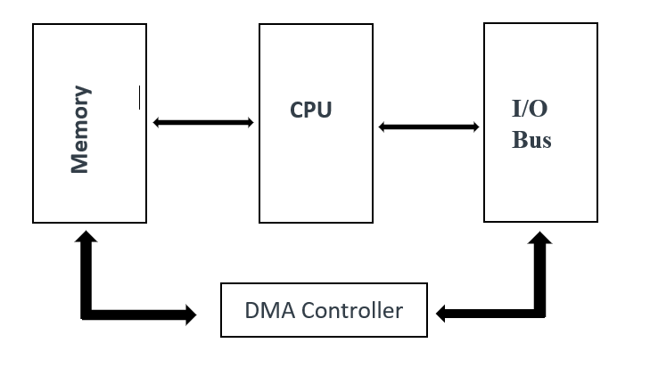
Figure 2: Block diagram representation DMA-Based I/O

// stm32f7_loop_DMA.c

/* Includes ------------------------------------------------------------------*/
#include "stm32f7_loop_DMA.h"

/* Private typedef -----------------------------------------------------------*/
/* Private define ------------------------------------------------------------*/
#define SOURCE_FILE_NAME "stm32f7_loop_DMA.c"

#define AUDIO_FREQ 16000u
#define AUDIO_IN_BIT_RES 16u
#define AUDIO_IN_CHANNEL_NBR 2u
#define BLOCK_SAMPLES_PER_CH 512u
#define BLOCK_SAMPLES_TOTAL (BLOCK_SAMPLES_PER_CH * AUDIO_IN_CHANNEL_NBR)
#define BUF_SAMPLES (BLOCK_SAMPLES_TOTAL * 2u)
/* Private macro -------------------------------------------------------------*/
/* Private variables ---------------------------------------------------------*/
static __attribute__((aligned(32))) uint16_t InBuf[BUF_SAMPLES];
static __attribute__((aligned(32))) uint16_t OutBuf[BUF_SAMPLES];

static __IO uint8_t InHalfComplete = 0;
static __IO uint8_t InFullComplete = 0;
static __IO uint8_t OutHalfComplete = 0;
static __IO uint8_t OutFullComplete = 0;
/* Private function prototypes -----------------------------------------------*/
static void MPU_Config(void);
static void SystemClock_Config(void);
static void CPU_CACHE_Enable(void);
static void Error_Handler(void);
void BSP_AUDIO_OUT_ClockConfig(SAI_HandleTypeDef *hsai, uint32_t AudioFreq, void *Params);

/* Private functions ---------------------------------------------------------*/
void BSP_AUDIO_IN_HalfTransfer_CallBack(void)
{
InHalfComplete = 1;
}

void BSP_AUDIO_IN_TransferComplete_CallBack(void)
{
InFullComplete = 1;
}

void BSP_AUDIO_OUT_TransferComplete_CallBack(void)
{
OutFullComplete = 1;
}

int main(void)
{
/* Configure the MPU attributes */
MPU_Config();

/* Enable the CPU Cache */
CPU_CACHE_Enable();

HAL_Init();

/* Configure the System clock to have a frequency of 216 MHz */
SystemClock_Config();

stm32f7_LCD_init(AUDIO_FREQ, SOURCE_FILE_NAME, NOGRAPH);

if (BSP_AUDIO_IN_OUT_Init(INPUT_DEVICE_DIGITAL_MICROPHONE_2,
OUTPUT_DEVICE_HEADPHONE,
AUDIO_FREQ,
AUDIO_IN_BIT_RES,
AUDIO_IN_CHANNEL_NBR) != AUDIO_OK)
{
Error_Handler();
}

BSP_AUDIO_OUT_SetAudioFrameSlot(CODEC_AUDIOFRAME_SLOT_02);

if (BSP_AUDIO_OUT_Play(OutBuf, sizeof(OutBuf)) != AUDIO_OK)
{
Error_Handler();
}

/* Start IN with ping-pong buffer. Size is in HALF-WORDS (uint16_t). */
if (BSP_AUDIO_IN_Record(InBuf, BUF_SAMPLES) != AUDIO_OK)
{
Error_Handler();
}

/* Forever loopback: copy halves from IN -> OUT as they become ready */
while (1)
{
/* Copy first half when recorded */
if (InHalfComplete)
{
InHalfComplete = 0;

memcpy(OutBuf, InBuf, BLOCK_SAMPLES_TOTAL * sizeof(uint16_t));

}

/* Copy second half when recorded */
if (InFullComplete)
{
InFullComplete = 0;

memcpy(OutBuf + BLOCK_SAMPLES_TOTAL,
InBuf + BLOCK_SAMPLES_TOTAL,
BLOCK_SAMPLES_TOTAL * sizeof(uint16_t));
}
}
}

Program Operation of stm32f7_loop_DMA.c
The operation of program stm32f7_loop_intr.c is as follows.
In function main(), an initialization function stm32f7_wm8994_init() is called. This configures the STM32F746G processor and WM8994 codec such that the codec will read (left and right channel) sample values from the digital microphones and interrupt the processor at a sampling frequency determined by the parameter AUDIO_FREQUENCY_48K passed to the function.
Parameter INPUT_DEVICE_DIGITAL_MICROPHONE_2 specifies that input to the WM8994 will come from the digital microphones on the STM32F746G Discovery board.
Parameter IO_METHOD_INTR passed to function stm32f7_wm8994_init()determines that interrupt, as opposed to DMA-based I/O, will be used by the program.
Parameter OUTPUT_DEVICE_HEADPHONE is redundant insofar as the headphone socket (CN10) is the only audio output currently supported in this DSP Education Kit.
Parameters WM8994_HP_OUT_ANALOG_GAIN_6DB, WM8994_LINE IN_GAIN_0DB, and WM8994_DMIC_GAIN_17DB concern the configuration of programmable gain blocks in the signal path through the codec.
Parameters SOURCE_FILE_NAME and NOGRAPH influence what will be shown on the Discovery board’s LCD.
There is no need to understand every detail of the initialization carried out by function stm32f7_wm8994_init(). After it has been called, interrupts generated by the Serial Audio Interface (SAI) peripheral in the STM32F746G microcontroller (to which the WM8994 codec is connected) will be enabled, and each time an interrupt occurs, the interrupt service routine function BSP_AUDIO_SAI_Interrupt_CallBack()will be called. One interrupt will occur per sampling period, and both left and right channel samples are processed in one call to function BSP_AUDIO_SAI_Interrupt_CallBack().
Following initialization, function main()enters an endless while() loop, doing nothing but waiting for interrupts.
When function BSP_AUDIO_SAI_Interrupt_CallBack() is called, new input sample values (from the WM8994 codec¹) may be read as variables rx_sample_L and rx_sample_R, and sample values written to variables tx_sample_L and tx_sample_R will be written to the WM8994 DAC at the next sampling instant.
¹Input sample values may have come either from the analog LINE IN socket (CN11) on the Discovery board, via the WM8994 ADC, or from the two digital microphones on the Discovery board, via a digital interface on the WM8994.
In stm32f7_loop_DMA.c, the program configures the MPU, enables instruction and data caches, calls HAL_Init(), and sets the system clock to 216 MHz. The LCD is initialized to display the source filename and 16 kHz sample rate. Audio is brought up full-duplex: BSP_AUDIO_IN_OUT_Init() selects the WM8994’s digital microphone pair (INPUT_DEVICE_DIGITAL_MICROPHONE_2) as input and headphones as output at 16 kHz, 16-bit, stereo. Headphone TDM is forced to the 0 & 2 slots with BSP_AUDIO_OUT_SetAudioFrameSlot(CODEC_AUDIOFRAME_SLOT_02). Playback is primed with BSP_AUDIO_OUT_Play() on a ping-pong output buffer, then capture starts with BSP_AUDIO_IN_Record() on a matching ping-pong input buffer (512 samples per channel per half). From there, DMA does the work. When the input buffer is half full, BSP_AUDIO_IN_HalfTransfer_CallBack() copies that half into the output buffer. When the input buffer is full, BSP_AUDIO_IN_TransferComplete_CallBack() copies the second half. The main loop remains idle while the callbacks continuously shuttle audio, yielding a steady 16 kHz → 16 kHz loopback with block-level latency and minimal CPU load—an ideal scaffold for inserting per-block real-time DSP inside the two callbacks.

Running the Program
The following steps assume that you have followed all the steps described in the Getting Started Guide provided with the labs.
To run the stm32f7_loop_DMA.c program, follow these steps:
- Open µVision 5 project Digital-Signal-Processing-Labs\Lab01_AnalogIO\Projects\STM32746G-Discovery\Lab01_AnalogIO\MDK-ARM\Project.uvprojx by double-clicking on its icon, similar to the one used in the Getting Started Guide.
- Right-click on the STM32F746_DISCOVERY folder in the Project pane and select Manage Project Items, after which you should get a window like the one shown in Figure 2 below:

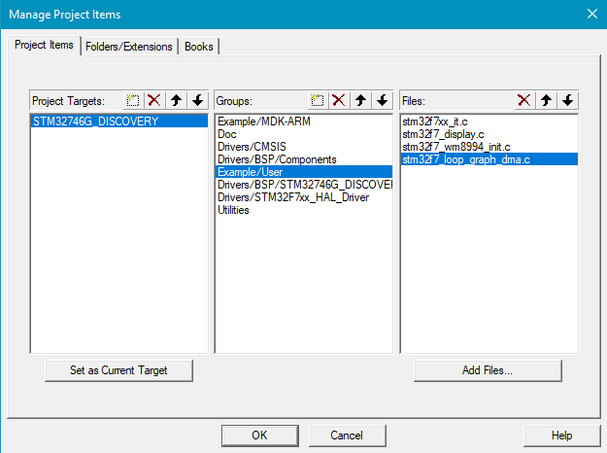
Figure 2: Screenshot of Manage Project Items

- Delete stm32f7_sine_lut_intr.c using the delete icon on the top right of the Files pane and then click on Add Files.
- Find stm32f7_loop_intr.c in the DSP Education Kit\Src folder and add it to the project. Click OK. You should now see a project structure like that shown in Figure 3.

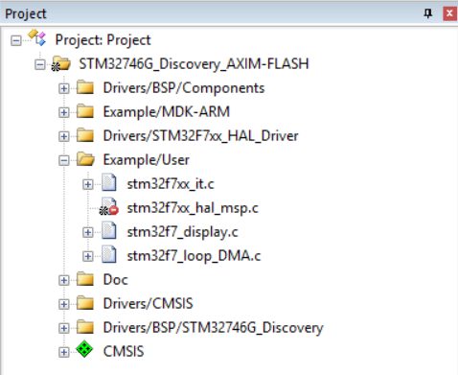
Figure 3: Screenshot of MDK-Arm showing the project
- Connect the STM32F746 Discovery board to the host PC using a USB A to Mini-B cable.
- Plug the headphones into the headset jack socket (CN10) on the board.
- Build the project by selecting the Project > Build target or by clicking on the Build toolbar button .
- After successfully building the project with no errors, switch to the debugger mode (and download the executable code into flash memory) by clicking on the Start/Stop Debug Session toolbar button .
- Once the Debugger View has appeared, click on the Run toolbar button .
- Once the program is running, you should see a start screen on the LCD on the board, as shown in Figure 4. You should be able to hear sounds picked up by the digital microphones on the STM32F746 Discovery board (micro right and micro left on the right side of the LCD screen). Depending on the characteristics of the headphones you are using, the sound may be loud or quiet. If you cannot hear anything, try blowing gently onto the microphones.

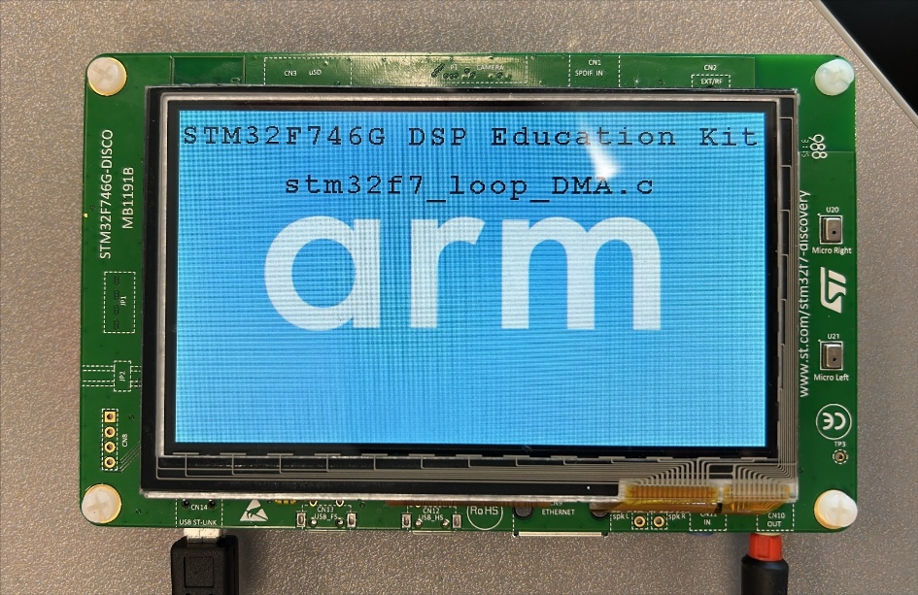
Figure 4: Start screen for program stm32f7_loop_DMA.c

Optional: If you would like to use an external microphone instead of the microphones on the board, you can pass the parameter INPUT_DEVICE_INPUT_LINE_1 instead of INPUT_DEVICE_DIGITAL_MICROPHONE_2) to function stm32f7_wm8994_init(). You can listen to a signal input either via the LINE IN (CN11) socket on the board or via the digital microphones on the Discovery board. You can do this by editing the source file stm32f7_loop_intr.c, re-building the project, downloading, and running the program.

Use of GPIO Pin for Timing Indication
In several example programs, including stm32f7_loop_intr.c, the state (HIGH or LOW) of a GPIO pin is used so that we can obtain an indication of the execution of a program by connecting an oscilloscope to that pin.
In the case of program stm32f7_loop_intr.c, GPIO pin PI1 is toggled each time an interrupt occurs, i.e., in the interrupt service routine BSP_AUDIO_SAI_Interrupt_CallBack(), using program statement BSP_LED_Toggle(LED1).
GPIO pin PI1 is accessible via pin D13 on connector CN7 and drives the green LED (LD1) next to the black reset pushbutton (B2).
Since interrupts should occur once per sampling period, the expected signal on GPIO pin PI1 is a square wave of frequency 24 kHz (if the sampling rate is 48 kHz).

Connect an Oscilloscope Probe to Pin D13 on Connector CN7 to Confirm Timing
GPIO pin PI1 may be set (HIGH) or reset (LOW) using program statements
BSP_LED_On(LED1);
BSP_LED_Off(LED1);

Alternatively, GPIO pin PI2, accessible via pin D8 on connector CN7 but not connected to an LED, may be set (HIGH), reset (LOW), or toggled using program statements:

BSP_GPIO_On();
BSP_GPIO_Off();
BSP_GPIO_Toggle();

Delaying the Signal
Some simple, yet striking, effects can be achieved by delaying the samples as they pass from input to output. Program stm32f7_delay_intr.c demonstrates this.
A delay line is implemented using the array buffer to store samples as they are read from the digital microphones. Once the array is full, the pointer bufptr is reset and the program overwrites the oldest stored input sample with the newest input sample. Just prior to overwriting the oldest stored input sample in buffer, that sample is retrieved, added to the current input, and written to the WM8994 DAC. The length of the delay is determined by the value of the constant DELAY_BUF_SIZE. As supplied, this is equal to 24000 samples, corresponding to a delay of 500 ms at a sampling rate of 48 kHz.
The following code snippet shows the source code of stm32f7_delay_intr.c.
By simply delaying and feeding back past samples, you can create echo-like effects with very little code. In our updated stm32f7_delay.c, we record audio at 16 kHz (stereo) into a circular delay line, mix each new sample with the one from ~64 ms ago, and play the result back—all via DMA for minimal CPU load.
A fixed-size array DelayBuf of
BUF_SAMPLES = (16 000 Hz × 64 ms × 2 ch) / 1000 = 2 048 samples
holds the delayed audio. As each sample arrives (in the DMA half/full callbacks), the code:
- Reads the current input sample (in = buffer[i]).
- Retrieves the oldest sample from DelayBuf[bufptr].
- Sums them, clamping the result to the 16-bit range.
- Writes the mixed sample to the output half-buffer (out[i]).
- Stores the current input into DelayBuf[bufptr] (overwriting the oldest).
- Increments bufptr modulo BUF_SAMPLES so the line wraps around.
This Process-Delay step is invoked by the DMA half/full transfer callbacks (effectively between record and play), giving a consistent ~64 ms single-tap delay on the Discovery board’s headphone output.

/* Includes ------------------------------------------------------------------*/
#include "stm32f7_delay.h"

/* Private typedef -----------------------------------------------------------*/
/* Private define ------------------------------------------------------------*/
#define SOURCE_FILE_NAME "stm32f7_delay.c"
#define AUDIO_FREQ 16000u
#define AUDIO_IN_BIT_RES 16u
#define AUDIO_IN_CHANNEL_NBR 2u
#define BLOCK_SAMPLES_PER_CH 512u
#define BLOCK_SAMPLES_TOTAL (BLOCK_SAMPLES_PER_CH * AUDIO_IN_CHANNEL_NBR)
#define BUF_SAMPLES (BLOCK_SAMPLES_TOTAL * 2u)

/* Private macro -------------------------------------------------------------*/
/* Private variables ---------------------------------------------------------*/
static __attribute__((aligned(32))) uint16_t InBuf[BUF_SAMPLES];
static __attribute__((aligned(32))) uint16_t OutBuf[BUF_SAMPLES];
static __attribute__((aligned(32))) uint16_t DelayBuf[BUF_SAMPLES];

static __IO uint8_t InHalfComplete = 0;
static __IO uint8_t InFullComplete = 0;
static __IO uint8_t OutHalfComplete = 0;
static __IO uint8_t OutFullComplete = 0;

static uint32_t bufptr;

/* Private function prototypes -----------------------------------------------*/
static void MPU_Config(void);
static void SystemClock_Config(void);
static void CPU_CACHE_Enable(void);
static void Error_Handler(void);
static void ProcessDelay(const uint16_t *in, uint16_t *out, uint32_t length);
void BSP_AUDIO_OUT_ClockConfig(SAI_HandleTypeDef *hsai, uint32_t AudioFreq, void *Params);

/* Private functions ---------------------------------------------------------*/
void BSP_AUDIO_IN_HalfTransfer_CallBack(void)
{
ProcessDelay(InBuf, OutBuf, BLOCK_SAMPLES_TOTAL);
}

void BSP_AUDIO_IN_TransferComplete_CallBack(void)
{
ProcessDelay(InBuf + BLOCK_SAMPLES_TOTAL, OutBuf + BLOCK_SAMPLES_TOTAL, BLOCK_SAMPLES_TOTAL);
}

static void ProcessDelay(const uint16_t *in, uint16_t *out, uint32_t length)
{
for (uint32_t i = 0; i < length; i++) {
int16_t delayed = DelayBuf[bufptr];
int32_t sum = (int32_t)in[i] + (int32_t)delayed;

out[i] = (int16_t)sum;
DelayBuf[bufptr] = in[i];
bufptr = (bufptr + 1) % BUF_SAMPLES;
}
}

int main(void)
{
/* Configure the MPU attributes */
MPU_Config();

/* Enable the CPU Cache */
CPU_CACHE_Enable();

HAL_Init();

/* Configure the System clock to have a frequency of 216 MHz */
SystemClock_Config();

stm32f7_LCD_init(AUDIO_FREQ, SOURCE_FILE_NAME, NOGRAPH);

if (BSP_AUDIO_IN_OUT_Init(INPUT_DEVICE_DIGITAL_MICROPHONE_2,
OUTPUT_DEVICE_HEADPHONE,
AUDIO_FREQ,
AUDIO_IN_BIT_RES,
AUDIO_IN_CHANNEL_NBR) != AUDIO_OK)
{
Error_Handler();
}

BSP_AUDIO_OUT_SetAudioFrameSlot(CODEC_AUDIOFRAME_SLOT_02);

if (BSP_AUDIO_OUT_Play(OutBuf, sizeof(OutBuf)) != AUDIO_OK)
{
Error_Handler();
}

/* Start IN with ping-pong buffer. Size is in HALF-WORDS (uint16_t). */
if (BSP_AUDIO_IN_Record(InBuf, BUF_SAMPLES) != AUDIO_OK)
{
Error_Handler();
}

/* Infinite loop */
while (1);
}
Figure 5: Block diagram representation of program stm32f7_delay_intr.c

Creating a Fading Echo Effect
By feeding back a fraction of the output of the delay line to its input, a fading echo effect can be realized. The program stm32f7_echo.c, shown in the following code snippet, does this.
/* Includes ------------------------------------------------------------------*/
#include "stm32f7_echo.h"

/* Private typedef -----------------------------------------------------------*/
/* Private define ------------------------------------------------------------*/
#define SOURCE_FILE_NAME "stm32f7_echo.c"
#define AUDIO_FREQ 16000u
#define AUDIO_IN_BIT_RES 16u
#define AUDIO_IN_CHANNEL_NBR 2u
#define BLOCK_SAMPLES_PER_CH 512u
#define BLOCK_SAMPLES_TOTAL (BLOCK_SAMPLES_PER_CH * AUDIO_IN_CHANNEL_NBR)
#define BUF_SAMPLES (BLOCK_SAMPLES_TOTAL * 2u)

#define DELAY_BUF_SIZE 2000u
#define GAIN 0.6f
/* Private macro -------------------------------------------------------------*/
/* Private variables ---------------------------------------------------------*/
static __attribute__((aligned(32))) uint16_t InBuf[BUF_SAMPLES];
static __attribute__((aligned(32))) uint16_t OutBuf[BUF_SAMPLES];

static __IO uint8_t InHalfComplete = 0;
static __IO uint8_t InFullComplete = 0;
static __IO uint8_t OutHalfComplete = 0;
static __IO uint8_t OutFullComplete = 0;

static int16_t DelayBuf[DELAY_BUF_SIZE];
static uint32_t bufptr;

/* Private function prototypes -----------------------------------------------*/
static void MPU_Config(void);
static void SystemClock_Config(void);
static void CPU_CACHE_Enable(void);
static void Error_Handler(void);
static void ProcessDelay(const uint16_t *in, uint16_t *out, uint32_t length);
void BSP_AUDIO_OUT_ClockConfig(SAI_HandleTypeDef *hsai, uint32_t AudioFreq, void *Params);

/* Private functions ---------------------------------------------------------*/
void BSP_AUDIO_IN_HalfTransfer_CallBack(void)
{
ProcessDelay(InBuf, OutBuf, BLOCK_SAMPLES_TOTAL);
}

void BSP_AUDIO_IN_TransferComplete_CallBack(void)
{
ProcessDelay(InBuf + BLOCK_SAMPLES_TOTAL, OutBuf + BLOCK_SAMPLES_TOTAL, BLOCK_SAMPLES_TOTAL);
}

static void ProcessDelay(const uint16_t *in, uint16_t *out, uint32_t length)
{
for (uint32_t i = 0; i < length; i++) {
int16_t delayed = DelayBuf[bufptr];
int32_t sum = (int32_t)in[i] + (int32_t)delayed * GAIN;

out[i] = (int16_t)sum;
DelayBuf[bufptr] = sum;
bufptr = (bufptr + 1) % DELAY_BUF_SIZE;
}
}

int main(void)
{
/* Configure the MPU attributes */
MPU_Config();

/* Enable the CPU Cache */
CPU_CACHE_Enable();

HAL_Init();

/* Configure the System clock to have a frequency of 216 MHz */
SystemClock_Config();

stm32f7_LCD_init(AUDIO_FREQ, SOURCE_FILE_NAME, NOGRAPH);

if (BSP_AUDIO_IN_OUT_Init(INPUT_DEVICE_DIGITAL_MICROPHONE_2,
OUTPUT_DEVICE_HEADPHONE,
AUDIO_FREQ,
AUDIO_IN_BIT_RES,
AUDIO_IN_CHANNEL_NBR) != AUDIO_OK)
{
Error_Handler();
}

BSP_AUDIO_OUT_SetAudioFrameSlot(CODEC_AUDIOFRAME_SLOT_02);

if (BSP_AUDIO_OUT_Play(OutBuf, sizeof(OutBuf)) != AUDIO_OK)
{
Error_Handler();
}

/* Start IN with ping-pong buffer. Size is in HALF-WORDS (uint16_t). */
if (BSP_AUDIO_IN_Record(InBuf, BUF_SAMPLES) != AUDIO_OK)
{
Error_Handler();
}

/* Infinite loop */
while (1);
}

Exercise
Experiment with different values of the constants DELAY_BUF_SIZE and GAIN. The delay in seconds is equal to DELAY_BUF_SIZE divided by the sampling frequency in Hz, and the fraction of the delayed signal fed back is equal to GAIN.
What would happen if the value of GAIN were made greater than or equal to 1?
- Study the program listing in stm32f7_echo.c and, with reference to Figure 5, draw a block diagram of the system it implements in the space provided below. In the space below that, sketch what you think its response to a unit impulse at time t = 0 would be (with a GAIN of 0.6 and a DELAY_BUF_SIZE size of 2000 samples).

Block diagram representation of program stm32f7_echo.c:

Impulse response of program stm32f7_echo.c (DELAY_BUF_SIZE = 2000, GAIN = 0.6):

Real-Time Sine Wave Generation

Program Operation
The C source file stm32f7_sine_lut.c, shown in the code snippet below, generates a sinusoidal signal using interrupts and a table lookup method.
// stm32f7_sine_lut.c

/* Includes ------------------------------------------------------------------*/
#include "stm32f7_sine_lut.h" // your board/HAL declarations

/* Private defines -----------------------------------------------------------*/
#define SOURCE_FILE_NAME "stm32f7_sine_lut.c"
#define AUDIO_FREQ 8000u
#define LOOPLENGTH 8u

/* Private variables ---------------------------------------------------------*/
static __IO uint8_t PlayComplete = 0;
static int16_t sine_table[LOOPLENGTH] = {0, 7071, 10000, 7071, 0, -7071, -10000, -7071};
static int16_t stereo_buf[LOOPLENGTH * 2];

/* Private function prototypes -----------------------------------------------*/
static void MPU_Config(void);
static void SystemClock_Config(void);
static void CPU_CACHE_Enable(void);
static void Error_Handler(void);

int main(void)
{
/* Configure MPU, enable cache, HAL init, system clock */
MPU_Config();
CPU_CACHE_Enable();
HAL_Init();
SystemClock_Config();

/* LCD feedback */
stm32f7_LCD_init(AUDIO_FREQ, SOURCE_FILE_NAME, GRAPH);

/* Plot the raw 8-sample LUT on the LCD */
plotSamples(sine_table, LOOPLENGTH, 32);

/* Build interleaved stereo buffer */
for (uint32_t i = 0; i < LOOPLENGTH; i++){
stereo_buf[2*i] = sine_table[i]; // left slot
stereo_buf[2*i + 1] = sine_table[i]; // right slot
}

/* Init audio out @8 kHz */
if (BSP_AUDIO_OUT_Init(OUTPUT_DEVICE_HEADPHONE, 70, AUDIO_FREQ) != AUDIO_OK)
Error_Handler();

/* Force 2-slot (mono/stereo) mode */
BSP_AUDIO_OUT_SetAudioFrameSlot(CODEC_AUDIOFRAME_SLOT_02);

/* Play the 16-sample (8�2) buffer = 8 frames ? 1 kHz tone */
if (BSP_AUDIO_OUT_Play((uint16_t*)stereo_buf, LOOPLENGTH * 2 * sizeof(int16_t)) != AUDIO_OK){
Error_Handler();
}

/* Done, just sit and toggle LED on transfer-complete */
while (1){
if (PlayComplete){
PlayComplete = 0;
}
}
}

An eight-point lookup table is initialized using the array sine_table such that the value of sine_table[i] is equal to
$$\text{sine_table}[i]=10000\sin{(}(2πi/8)+φ)$$
where in this case, . The LOOPLENGTH values in array sine_table are samples of exactly one cycle of a sinusoid.
Just as in the previous examples, in function main(), the initialization function stm32f7_wm8994_init() is called. This configures processor and codec such that the WM8994 will sample, and interrupt the processor, at a frequency determined by the parameter value AUDIO_FREQUENCY_8K, i.e., in this case at 8 kHz. Interrupts will occur every 0.125 ms.
Following the call to function stm32f7_wm8994_init(), function main() enters an endless loop, doing nothing but waiting for interrupts (which will occur once per sampling period).
Upon an interrupt occurring, the interrupt service routine function BSP_AUDIO_SAI_Interrupt_CallBack() is called, and in that routine, the most important program statements are executed: the sample values read from array sine_table are written to both channels to the DAC and the index variable sine_ptr is incremented to point to the next value in the array.
The 1 kHz frequency of the sinusoidal output signal corresponds to the eight samples per cycle output at a rate of 8 kHz.
The WM8994 DAC is effectively a low pass reconstruction filter that interpolates between output sample values to give a continuous sinusoidal analog output signal as shown in Figure 6. This will be explained further in the next lab exercise.
In main(), after configuring the MPU, enabling caches, initializing HAL, and switching the system clock to 216 MHz, the LCD is brought up to display the filename and sample rate, and plotSamples() draws the eight discrete values as a bar graph. Next, we build a simple interleaved stereo buffer by copying each mono sample into both left and right channels. We then initialize the WM8994 codec for 8 kHz output and immediately force a 2‐slot TDM frame so that our eight‐sample buffer spans eight audio frames (rather than the default four).
Because we output eight samples at an 8000 Hz rate, the result is a 1000 Hz sine wave (8000 Hz ÷ 8 = 1000 Hz). The WM8994’s onboard reconstruction filter smooths the discrete steps into a continuous analog waveform, exactly as sketched in the original figure. When you load and run this program, you should first see the start screen and bar‐graph of sample values. If you connect the headphone jack to an oscilloscope you will observe a clean 1 kHz sine tone in both the time and frequency domains.
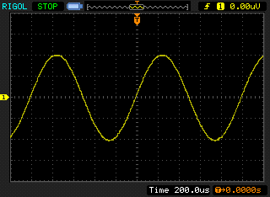
Figure 6: Analog output generated by program stm32f7_sine_lut.c

When you run the program, you should see a start screen on the LCD as shown in Figure 7. Press the blue user pushbutton to continue, and you should see a graphical representation of the sequence of discrete sample values being written to the DAC (Figure 8). The sample values are represented as bars in the graph on the LCD to emphasize that it is the discrete sample values written to the DAC that are being shown and not the continuous-time signal output by the DAC. Connect one channel of the audio card HEADPHONE OUT output to an oscilloscope and verify that the output signal is a 1 kHz sinusoid using both time-domain and frequency-domain oscilloscope displays.

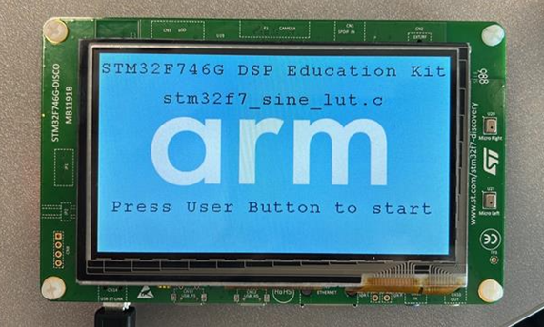
Figure 7: Start screen for program stm32f7_sine_lut.c

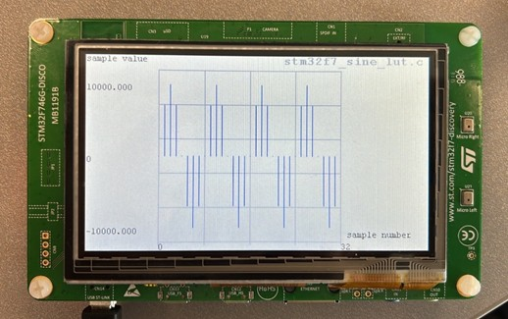
Figure 8: Graphical representation of first 32 sample values output by program stm32f7_sine_lut.c

Exercise: Modifying the Sine Wave
Edit the source file stm32f7_sine_lut.c to generate
1. A 500 Hz sinusoid
2. A 2000 Hz sinusoid
3. A 3000 Hz sinusoid
You should be able to achieve these simply by changing the initialized contents of the array sine_table (and by changing the value of the constant LOOPLENGTH accordingly). Do not change any other program statements. Record the combinations of LOOPLENGTH and sine_table with which you achieve these results in the space below.

500 Hz sinewave
LOOPLENGTH =
sine_table =

2000 Hz sinewave
LOOPLENGTH =
sine_table =

3000 Hz sinewave
LOOPLENGTH =
sine_table =

Viewing Program Output Using MATLAB
To view your program output in MATLAB, you can first store the output values into a file and then use MATLAB to load the values from the saved file.
stm32f7_sine_lut_buf.c shows how to store the output values. It is very similar to the program stm32f7_sine_lut.c, but it also stores the most recent BUFFER_LENGTH number of output values in the array buffer. The array buffer is of type float32_t for compatibility with the MATLAB function that will be used to view its contents.
To save the program output into a file and view them in MATLAB, follow these steps:
- Run the program and press the user button to start the program.
- Halt it by clicking on the Stop toolbar button in the MDK_Arm debugger.
- Type the variable name buffer as the Address in the debugger’s Memory 1 window. Right-click on the Memory 1 window and set the displayed data type to Decimal and Float as shown in Figure 9.
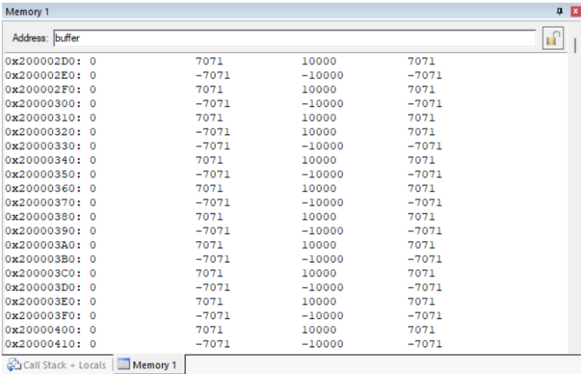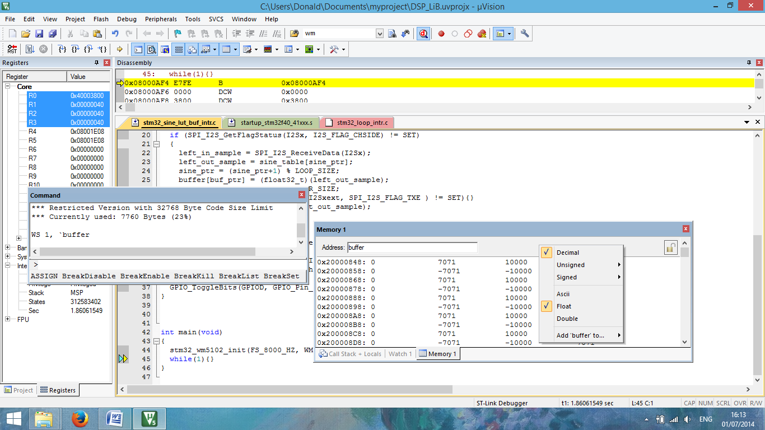
Figure 9: Memory 1 window showing the contents of array buffer

The start address of array buffer will be displayed in the top left-hand corner of the window.
- Use the following command at the prompt in the debugger’s Command window to save the contents of array buffer to a file in your project folder.
SAVE <filename> <start address>, <end address>
The end address should be the start address plus 0×190 (bytes) representing 100 32-bit sample values. For example,
SAVE sinusoid.dat 0×200002D0, 0×20000460
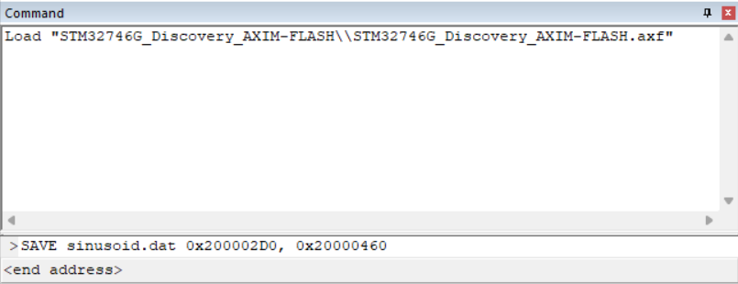
Figure 10: Saving data to file in MDK-Arm

- Launch MATLAB and run the MATLAB function stm32f7_logfft.m (provided with the DSP Education Kit in Lab01_AnalogIO\Projects\STM32746G-Discovery\Lab05_MATLAB\Matlab_Lab_Files\stm32f7_logfft.m) to obtain a graphical representation of the contents of the buffer. The MATLAB function will require you to input some information, such as the saved .dat filename (full path) and sampling frequency.

DMA-Based Example Program
Direct Memory Access (DMA) is a method in which a hardware component of a computer gains access to the Memory Bus and controls the transfer. DMA controllers can be configured to handle data transfers between memories, memory to peripherals, and vice versa, allowing the processor to deal with other processes. Essentially, the main benefit of this method is to reduce strain on the CPU. This concept is demonstrated in the block diagram below:


Figure 11: Block diagram representation DMA-Based I/O

Program stm32f7_loop_graph_dma.c. has similar functionality to program stm32f7_loop_intr.c except that it uses the DMA I/O, as opposed to using an interrupt-based method. DMA-based I/O is investigated in more detail in Lab 5.
Run program stm32f7_loop_graph_dma.c and confirm that input to the digital microphones is passed to the headphones. A major difference between programs stm32f7_loop_intr.c and stm32f7_loop_graph_dma.c is that the latter program plots the sample values it writes to the WM8994 DAC as a graph on the LCD. Pressing the blue user pushbutton toggles between time-domain and frequency-domain representations of those sample values.
// stm32f7_loop_graph_dma.c

#include "stm32f7_wm8994_init.h"
#include "stm32f7_display.h"

#define PLOTBUFSIZE 128

#define BLOCK_SIZE 1

#define SOURCE_FILE_NAME "stm32f7_loop_graph_dma.c"

extern volatile int32_t TX_buffer_empty; // these may not need to be int32_t
extern volatile int32_t RX_buffer_full; // they were extern volatile int16_t in F4 version
extern int16_t rx_buffer_proc, tx_buffer_proc; // will be assigned token values PING or PONG

float32_t x[PING_PONG_BUFFER_SIZE];

float32_t cmplx_buf[2*PING_PONG_BUFFER_SIZE];
float32_t outbuffer[PING_PONG_BUFFER_SIZE] = { 0.0f };

void process_buffer(void) // this function processes one DMA transfer block of data
{
int i;
int16_t *rx_buf, *tx_buf;

Conclusions
You should now be familiar with several of the tools and techniques that you will use in subsequent lab exercises.

Additional References
Link to Board information and resources:
https://www.st.com/en/evaluation-tools/32f746gdiscovery.html#overview
Using DMA controllers in STM Discovery boards:
https://www.st.com/content/ccc/resource/technical/document/application_note/27/46/7c/ea/2d/91/40/a9/DM00046011.pdf/files/DM00046011.pdf/jcr:content/translations/en.DM00046011.pdf
For more details about DMA:
http://cires1.colorado.edu/jimenez-group/QAMSResources/Docs/DMAFundamentals.pdf

